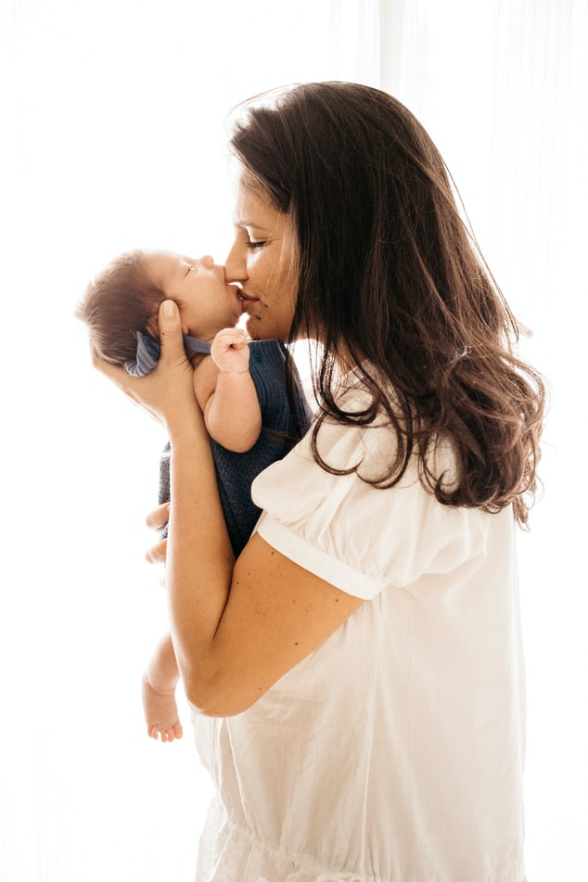

Life is Precious

281-427-2273

www.prcebaytown.org

Life is Precious

281-427-2273

www.prcebaytown.org

[“The King will reply, ‘Truly I tell you, whatever you did for one of the least of these brothers and sisters of mine, you did for me.’](https://www.bible.com/bible/111/MAT.25.40.NIV) ~Matthew 25:40

[“The King will reply, ‘Truly I tell you, whatever you did for one of the least of these brothers and sisters of mine, you did for me.’](https://www.bible.com/bible/111/MAT.25.40.NIV) ~Matthew 25:40

Pregnancy Resource Center East

281-427-2273

www.prcebaytown.org

Pregnancy Resource Center East

281-427-2273

www.prcebaytown.org

Life is Precious

Life is Precious

Everyday thousands of women have abortions because they feel they have no other choice. Our culture has encouraged the exercise of this constitutional right since 1973 & Roe vs Wade, and it’s becoming more intense today.

Can the Church Make a Difference?

Partnering with Pregnancy Resource Center East you can! We work with clients on an individual basis to meet their needs, to share the gospel, and options that will allow them to choose life for their unborn child.

We help in preventing unwanted pregnancies by educating youth to save sex for marriage. We offer help with healing and forgiveness through post-abortion Bible Study.

Volunteers are always needed, whatever your talents and time you can have an impact!

All our services are FREE to clients; PRCE depends on the Church and community for funding. Your financial support will allow us to continue to reach mothers, babies, and families.

Everyday thousands of women have abortions because they feel they have no other choice. Our culture has encouraged the exercise of this constitutional right since 1973 & Roe vs Wade, and it’s becoming more intense today.

Can the Church Make a Difference?

Partnering with Pregnancy Resource Center East you can! We work with clients on an individual basis to meet their needs, to share the gospel, and options that will allow them to choose life for their unborn child.

We help in preventing unwanted pregnancies by educating youth to save sex for marriage. We offer help with healing and forgiveness through post-abortion Bible Study.

Volunteers are always needed, whatever your talents and time you can have an impact!

All our services are FREE to clients; PRCE depends on the Church and community for funding. Your financial support will allow us to continue to reach mothers, babies, and families.