FETAL DEVELOPMENT ASSESSMENT

- The Biblical view of children are a __________________ from the Lord?
- The World View: Children should be _____________ or ____________.
- This a picture of the ________________ system.

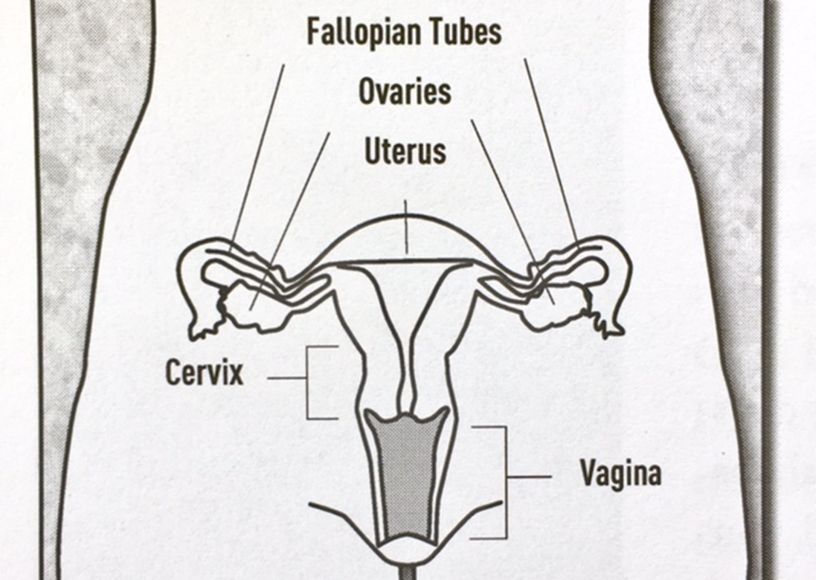

- Pituitary gland in the woman’s brain sends hormones to stimulate the ovaries to release an egg. TRUE or FALSE
- Name 3 signs and symptoms of pregnancy; 1. _____________, 2. ______________ and 3. __________________.
- Pregnancy Test measures what hormone ___________________________.
- At PRCE we believe that “Life begins at fertilization, not at implantation.” There are several birth control methods that have the potential to destroy a fertilized egg or prevent it from implanting and that is viewed as an abortifacient. So, we do not _____________, _______________, or ______________ any birth control methods at our center.

- First trimester ______ weeks, second trimester ______weeks and third trimester ______.
- Ultrasounds ________________ __________________.
- ________ % of women change their minds after seeing an ultrasound.
- To be eligible for ultrasounds, clients at PRCE must be ________ to ________ weeks.
Bonus questions: After the Texas Heartbeat bill of 2021 abortions in Texas fell by ________ % in the first month of after becoming law.

